**VAQ Healthy Living Guide**

**Software Requirements Specification**

Version 1.0

November 2, 2017

**Lead Software Engineer:**

Stephen Izquierdo

**Project Team:**

Gabriel Garcia

Dulio Gomez

Edward Jones

Reyna Maximino

Yessenia Rodriguez

Jacob Shircliff

Edson Trejo Hernandez

Prepared for

Software Engineering

Instructor: MK Quweider, Ph.D.

Fall 2017

**Table of Contents**

Revision History ii

Document Approval ii

1. Introduction 1

1.1 Purpose 1

1.2 Scope 1

1.3 Definitions, Acronyms, and Abbreviations 1

1.4 References 2

1.5 Overview 2

2. General Description 2

2.1 Product Perspective 2

2.2 Product Functions 2

2.3 User Characteristics 3

2.4 General Constraints 3

2.5 Assumptions and Dependencies 3

3. Specific Requirements 3

3.1 External Interface Requirements 3

3.1.1 User Interfaces 3

3.1.2 Hardware Interfaces 4

3.1.3 Software Interfaces 4

3.1.4 Communications Interfaces 4

3.2 Functional Requirements 4

3.2.1 Store User Login Credentials 4

3.2.2 Store Collected Medical Information 4

3.2.3 Retrieve Individual Collected Medical Information for Viewing and Editing 5

3.2.4 Retrieve Individual or All collected Exercise Information for Viewing 5

3.3 Use Cases 6

3.3.1 Use Case #1 6

3.3.2 Use Case #2 6

3.4 Classes / Objects 6

3.4.1 <Class / Object #1> 6

3.4.2 <Class / Object #2> 6

3.5 Non-Functional Requirements 6

3.5.1 Performance 6

3.5.2 Reliability 6

3.5.3 Availability 6

3.5.4 Security 6

3.5.5 Maintainability 7

3.5.6 Portability 7

3.6 Inverse Requirements 7

3.7 Design Constraints 7

3.8 Logical Database Requirements 7

3.9 Other Requirements 7

4. Analysis Models 7

4.1 Sequence Diagrams 7

4.3 Data Flow Diagrams (DFD) 7

4.2 State-Transition Diagrams (STD) 7

5. Change Management Process 7

A. Appendices 8

A.1 Appendix 1 8

A.2 Appendix 2 8

# 1. Introduction

## 1.1 Purpose

The purpose of the Software Requirements Specification is to provide a detailed description of the VAQ Healthy Living Guide application. The SRS will describe the purpose and features of this application, detailing its external interfaces, constraints, logical databases, and functionality attributes. Outlining its design and implementation, this document will provide a clear description of the software for the customers, one of the intended audience. Other intended audiences include developers, users, and business managers.

## 1.2 Scope

The software application being described in this document is the VAQ Healthy Living Guide application. This application may be used by anyone, but students and faculty of the University of Rio Grande Valley are who it was mainly designed for. This was done with the purpose of helping and guiding them to live a healthier life.

Using a graphical user interface, the user will be allowed to input one’s medical information then stored in a MySQL database. Additional information is already stored in pre-existing databases with food nutritional and exercise routine information. Using this data, recommendations of a healthy diet will be given to the user in the Healthy Diet tab. Under this tab, users will also be able to find the different food categories and get information on them. These recommendations and diet information may be generated into a PDF document by the user and sent to oneself via email. A calories calculator service will also be provided in this tab. Furthermore, also based on the medial information provided, exercise routine recommendations will be made under a tab titled Exercise. Additional information on different exercise routines can also be found in this tab along with the machines, or equipment, needed to do them. Finally, there will be a tab called General information. This tab will have university contacts, local organization contacts, and website links to provide other ways the user can obtain further information or assistance on achieving a healthy life.

We will be focused on two out of the four tabs. These tabs will be the one centered on users’ medical information, titled Profile, and the tab titled Exercise.

## 1.3 Definitions, Acronyms, and Abbreviations

The following terms, acronyms, and abbreviations are used throughout this document and are presented in the table below.

|  |  |
| --- | --- |
| **Term** | **Definition** |
| SRS | Software Requirement Specification |
| GUI | Graphical User Interface |
| Database | A structured set of data held in a computer, especially one that is accessible in various ways. |
| MySQL | My Structured Query Language: open source relational database management system. |
| PDF | Portable Document Format |
| GitHub | GitHub is a web-based Git or version control repository and Internet hosting service, used by software developing teams. |
| Java Virtual Machine | Allows a java program to run on any platform, regardless of the operating system, without having to modify the code. |
| Wizard | A sequential set of prompts used in data collection, organized for ease of use for the user. |

## 1.4 References

GitHub – <https://github.com/>

MySQL – <https://www.mysql.com/>

JavaFX – <https://docs.oracle.com/javase/8/javase-clienttechnologies.htm>

NetBeans – <https://netbeans.org/>

Gluon - <http://gluonhq.com>

## 1.5 Overview

The following content below consist of 5 sections: General Description, Specific Requirements, Analysis Models, Change Management Process, and the Appendices. The General Description section’s goal is to describe and clarify the VAQ Healthy Living Guide application’s requirements easier to comprehend from a general view, particularly for end-users. While this may be true, the Specific Requirements will describe these requirements in detail, including the technical information developers need. Due to this team only working on specific tabs, only the requirements pertaining to these tabs will be explained in this section. Furthermore, the Analysis Models section provides all the models used to develop the requirements mentioned in the previous section. This section is subject to much change since the first version of the VAQ Healthy Living Guide is constantly undergoing change and many requirements still need to be met. The Change Management Process section outlines these changes and the procedures needed to follow when these changes occur. Finally, the Appendices section includes any conceptual documents and diagrams used by the developers. These documents may be used, or referenced, in requirements’ definitions, but this is specified for each document.

# 2. General Description

## 2.1 Product Perspective

The VAQ Healthy Living Guide product is independent in that it does not encapsulate another product. However, it will use MySQL to create databases, but this will require any additional action from the user.

## 2.2 Product Functions

In general, the VAQ Healthy Living Guide application will have the following functions:

* Store user login credentials.
* Store collected medical information.
* Retrieve individual collected medical information for viewing or editing.
* Store into a MySQL database various food nutritional information.
* Retrieve individual collected nutritional information for viewing.
* Generate dietary recommendations from collected user medical information.
* Generate distributable PDF files of the dietary information provided.
* Email the generated files to the user for personal use.
* Store into a MySQL database exercise routines and the equipment required.
* Retrieve individual or all collected exercise information for viewing.
* Generate exercise recommendations from collected user medical information.
* Prompt the user for information.
* Provide a system create a new user login.
* Provide a system to rese a forgotten user password.

## 2.3 User Characteristics

The VAQ Healthy Living Guide application is mainly designed for students and faculty of the University of Texas Rio Grande Valley. While this is the case, others who wish to pursue a healthy life can use it. The VAQ Healthy Living Guide can also be used to simple obtain information on nutrition and exercise routines.

## 2.4 General Constraints

In a general view, the developers of the VAQ Healthy Living Guide application will have the following constraints:

* It must be developed using NetBeans IDE.
* Its GUI must be JavaFX-based.
* It must be MySQL database-drive.
* Git and GitHub must be used for version control.

## 2.5 Assumptions and Dependencies

In a general view, the developers of the VAQ Healthy Living Guide application assume and or are depending on the following:

* It is assumed that VAQ Healthy Living Guide will run or be able to connect to a MySQL server and have the capabilities to connect to said database server.

# 3. Specific Requirements

## 3.1 External Interface Requirements

### 3.1.1 User Interfaces

The user will interface with a GUI provided by VAQ Healthy Living. This interface will have all the functionalities necessary to accomplish the user’s goal – creating a medical profile, getting nutritional and exercise routine information, dietary and exercise routine recommendations, and further resources of how to live a healthy guide.

### 3.1.2 Hardware Interfaces

VAQ Healthy Living Guide application required a mouse, keyboard, and monitor that are typical for a personal computer or desktop machine. Additionally, the hardware required is the hardware of a modern computer.

### 3.1.3 Software Interfaces

VAQ Healthy Living Guide is a Java program. Therefore, interfaces with Java Virtual Machine will be needed to run the program on whichever platform. In addition, it must also run simultaneously with a MySQL server, which connectivity will be included in the software.

### 3.1.4 Communications Interfaces

VAQ Healthy Living Guide can connect to a MySQL server which may require Internet connection. Furthermore, the application can also send files to the user’s email as attachments which also requires Internet connection. The communication between a MySQL server and the product are done through a driver that is embedded within the software.

## 3.2 Functional Requirements

### 3.2.1 Store User Login Credentials

3.2.1.1 Introduction

VAQ Healthy Living Guide stores the user’s email and password in a database.

3.2.1.2 Inputs

The user must provide their preferred email and password.

3.2.1.3 Processing

VAQ Healthy Living Guide will allow the user access after they provide their credentials stored.

3.2.1.4 Outputs

Upon entering their credentials, the user will be given access to the rest of the application and its services – including their stored information.

3.2.1.5 Error Handling

The application verifies the email and password provided are correct when the user is logging in.

### 3.2.2 Store Collected Medical Information

3.2.2.1 Introduction

VAQ Healthy Living Guide provides a sequential of prompts, or ‘wizard,’ to gather the user’s medical information into a database.

3.2.2.2 Inputs

The user must provide their personal, medical and allergy information. The specific fields were chosen passed on medical forms used in clinics. These forms can be found in Appendix. The user must also click on ‘Save’ button to store all their data.

3.2.2.3 Processing

VAQ Healthy Living Guide stores the collected data in the ‘personalinfo_user’, ‘personalinfo_user_allergies’ and ‘personalinfo_user_diseases’ tables of the database.

3.2.2.4 Outputs

The data stored will be displayed after the user clicks the ‘Save’ button.

3.2.2.5 Error Handling

VAQ Healthy Living Guide ensures proper inputs were provided.

### 3.2.3 Retrieve Individual Collected Medical Information for Viewing and Editing

3.2.4.1 Introduction

VAQ Healthy Living Guide provides the user the chance to view their information and make changes if they want to.

3.2.3.2 Inputs

The data is already on displayed when the user clicks on the specified tab of their profile they wish to view – either ‘Personal’, ‘Medical’, or ‘Allergies’. The user must click on a button to edit stored information.

3.2.3.3 Processing

VAQ Healthy Living Guide makes the changes on the stored data in the databases.

3.2.3.4 Outputs

The changes made are and the rest of the stored information is displayed on the screen for the respective tab the user is in and modified.

3.2.3.5 Error Handling

VAQ Healthy Living Guide ensures proper inputs for the changed attributes were provided.

### 3.2.4 Retrieve Individual or All collected Exercise Information for Viewing

3.2.4.1 Introduction

VAQ provides the user with information of exercise routines and the respective equipment needed for these routines. It allows the user to select a specific exercise routine from a list made of recommended exercise for the user and view more information on that exercise routine.

3.2.4.2 Inputs

The user must select the exercise routine they want to view the information off.

3.2.4.3 Processing

VAQ Healthy Living Guide retrieves the data from the table ‘exercise’ of the database and displays it.

3.2.4.4 Outputs

The exercise routine’s name, work out time, calories burned, difficulty, description, and an image are displayed on the right for the user to view.

3.2.4.5 Error Handling

VAQ Healthy Living Guide sanitizes inputs to ensure the software operates at its best.

…

### 3.3.1 Create a VAQ_Health Account

**Goal:** User creates account

**Input:** username/password

**Output:** Nothing

**Main Scenario**: User creates an account to store user login credentials

**Pre-Condition:** VAQ_Health must be running

### 3.3.2 User enters profile information

**Goal:** User enters profile information

**Input:** Personal, medical, and user Allergy information.

**Output:** GUI will output a notification if the save is successful

**Main Scenario:** User enters profile information and the application saves the data to a database.

**Pre-Condition:** VAQ_Health must be running

## 3.4 Classes / Objects

### 3.4.1 Personal

**3.4.1.1 Attributes**

* First name
* Last name
* Address
* City
* State
* Zip code
* Email
* Birthday
* Sex

**3.4.1.2 Functions**

* toString – Prints out the fields in a formatted output

### 3.4.2 Allergy

### 3.4.2.1 Description: Contains allergies as data members (Needs to be changed to a database)

### 3.4.2.2 Attributes:

### Boolean dairy;

### Boolean soy;

### Boolean eggs;

### Boolean peanuts;

### Boolean fish;

### Boolean wheat;

### Boolean sesame;

### Boolean gluten;

### Boolean lactose;

### Boolean fructose;

### Boolean sulfites;

### Boolean histamines;

### Boolean nitrites;

### Boolean nightshades;

### Boolean fructans;

### 3.4.3 Medical (Needs to be changed to diseases)

### 3.4.3.1 Description: Contains diseases as data members

### 3.4.3.3 Attributes:

* String weight;
* String height;
* Boolean hasDiabetes;
* Boolean hasHighCholesterol;
* Boolean hasCeliacDisease;
* Boolean hasKidneyDisease;
* Boolean hasHighBloodPressure;
* Boolean hasGout;

### 3.4.4 Profile

### 3.4.41 Description: Contains the profile information for the user

### 3.4.4.2Attributes:

* Medical medical
* Personal personal
* Allergy allergy

**3.4.4.3 Functions**

* **Login**

### 3.4.5 Exercise

### 3.4.5.1 Description: Contains information for a exercise routine

### 3.4.5.2Attributes:

* Double WorkoutLength
* Double CaloriesBurned
* Enum Difficulty
* Enum exerciseType

**3.4.3.3 Functions**

**(None implemented yet)**

## 3.5 Non-Functional Requirements

Non-functional requirements may exist for the following attributes. Often these requirements must be achieved at a system-wide level rather than at a unit level. State the requirements in the following sections in measurable terms (e.g., 95% of transaction shall be processed in less than a second, system downtime may not exceed 1 minute per day, > 30 day MTBF value, etc).

### 3.5.1 Performance

There are no performance requirements at this stage of the development stage. Nevertheless, the application will perform under normal standards.

### 3.5.2 Reliability

There are no reliability requirements at this stage of the development stage. Nevertheless, the goal is to reach maximum reliability.

### 3.5.3 Availability

The stored information for any user must be available upon request, provided all conditions – such as database server and other external aspects – are not failing.

### 3.5.4 Security

The following system in place requires users to login with an email and password. Nevertheless, there is not much at this stage in the development stage to ensure security of users’ data.

### 3.5.5 Maintainability

No maintainability requirements have been defined at this stage by the customer.

### 3.5.6 Portability

No maintainability requirements have been defined at this stage by the customer. Nevertheless, it must be portable to any machine with any operation system in which a Java Virtual Machine exists.

## 3.6 Inverse Requirements

State any *useful* inverse requirements.

## 3.7 Design Constraints

Specify design constrains imposed by other standards, company policies, hardware limitation, etc. that will impact this software project.

## 3.8 Logical Database Requirements

Will a database be used? If so, what logical requirements exist for data formats, storage capabilities, data retention, data integrity, etc.

## 3.9 Other Requirements

Catchall section for any additional requirements.

# 4. Analysis Models

There are no models at this moment. However, an initial data model can be found I Appendix.

## 4.1 Sequence Diagrams

There are no sequence diagrams at this stage of the development process.

## 4.3 Data Flow Diagrams (DFD)

There are no data flow diagrams at this stage of the development process.

## 4.2 State-Transition Diagrams (STD)

There are no state-transition diagrams at this stage of the development process.

# 5. Change Management Process

The following procedures are required when changing this SRS document.

* Suggested changes are made by editing the document in GitHub.
* The project manager will examine the changes, and if approved, will inform the team about the changes.
* If changes are dictated by customer, the Project Manager will create an updated copy or inform a team member of what needs to be changed and said member will create the updated copy with a signed document found in Appendix 1.
* The project manager will present the SRS document for final approval from the customer. The customer will also sign the document found in Appendix after this.
* After both the project manager and the customer approve the updates to the SRS document, the updated SRS will be uploaded to GitHub.
* The procedure for recording changes is recorded in the document found in Appendix 2.

# A. Appendices

## A.1 Appendix 1

Required form for approval of changes to this document.

# Document Approval

The following Software Requirements Specification has been accepted and approved by the following:

|  |  |  |  |
| --- | --- | --- | --- |
| **Signature** | **Printed Name** | **Title** | **Date** |
|  | Izquierdo Stephen | Lead Software Eng. |  |
|  | Dr. M. K. Quweider | Instructor, CSCI-3340 |  |
|  |  |  |  |

## A.2 Appendix 2

Required form needed if there are any changes after the document is completed.

# Revision History

|  |  |  |  |  |
| --- | --- | --- | --- | --- |
| **Date** | **Description** | | **Author** | **Comments** |
| 11/2/2017 | Version 1.0 | Yessenia Rodriguez, Stephen Izquierdo | | First Draft |
|  |  |  | |  |
|  |  |  | |  |
|  |  |  | |  |

## A.3 Appendix 3

The following are medical forms used to consider what information to gather from users.

A screenshot of a social media post

Description generated with very high confidence A screenshot of a cell phone

Description generated with very high confidence

A screenshot of a cell phone

Description generated with very high confidence

## A.4 Appendix 4

The following is an early stage of the personal GUI design.

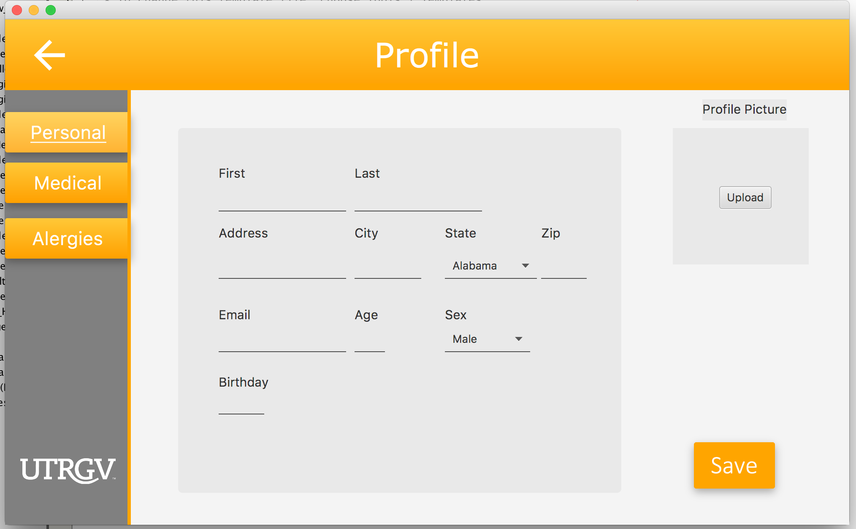

## A.5 Appendix 5

The following is an early stage of the medical GUI design.

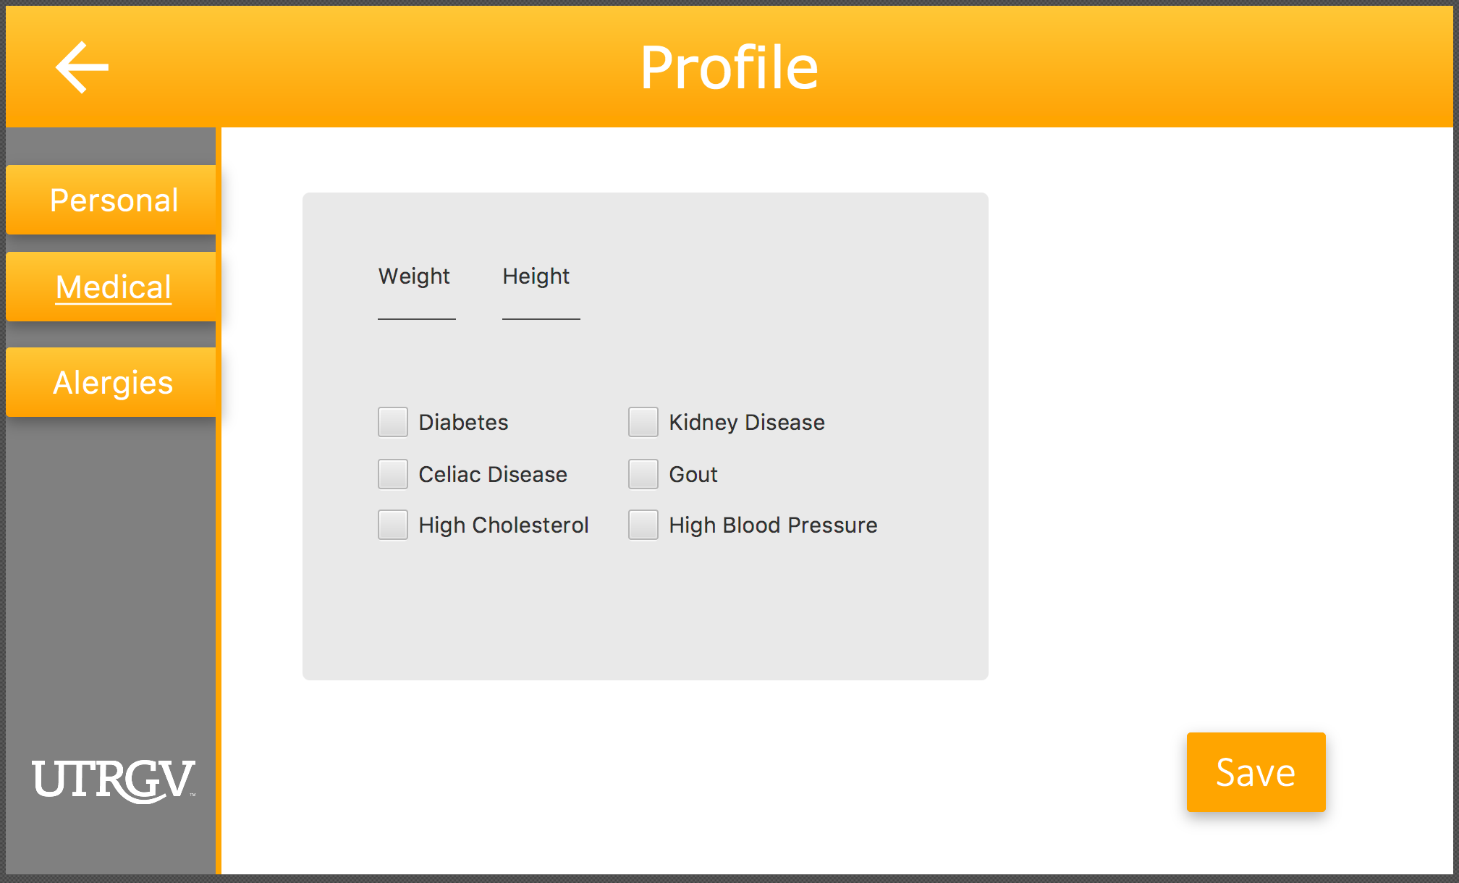

## A.6 Appendix 6

The following is an early stage of the allergies GUI design.

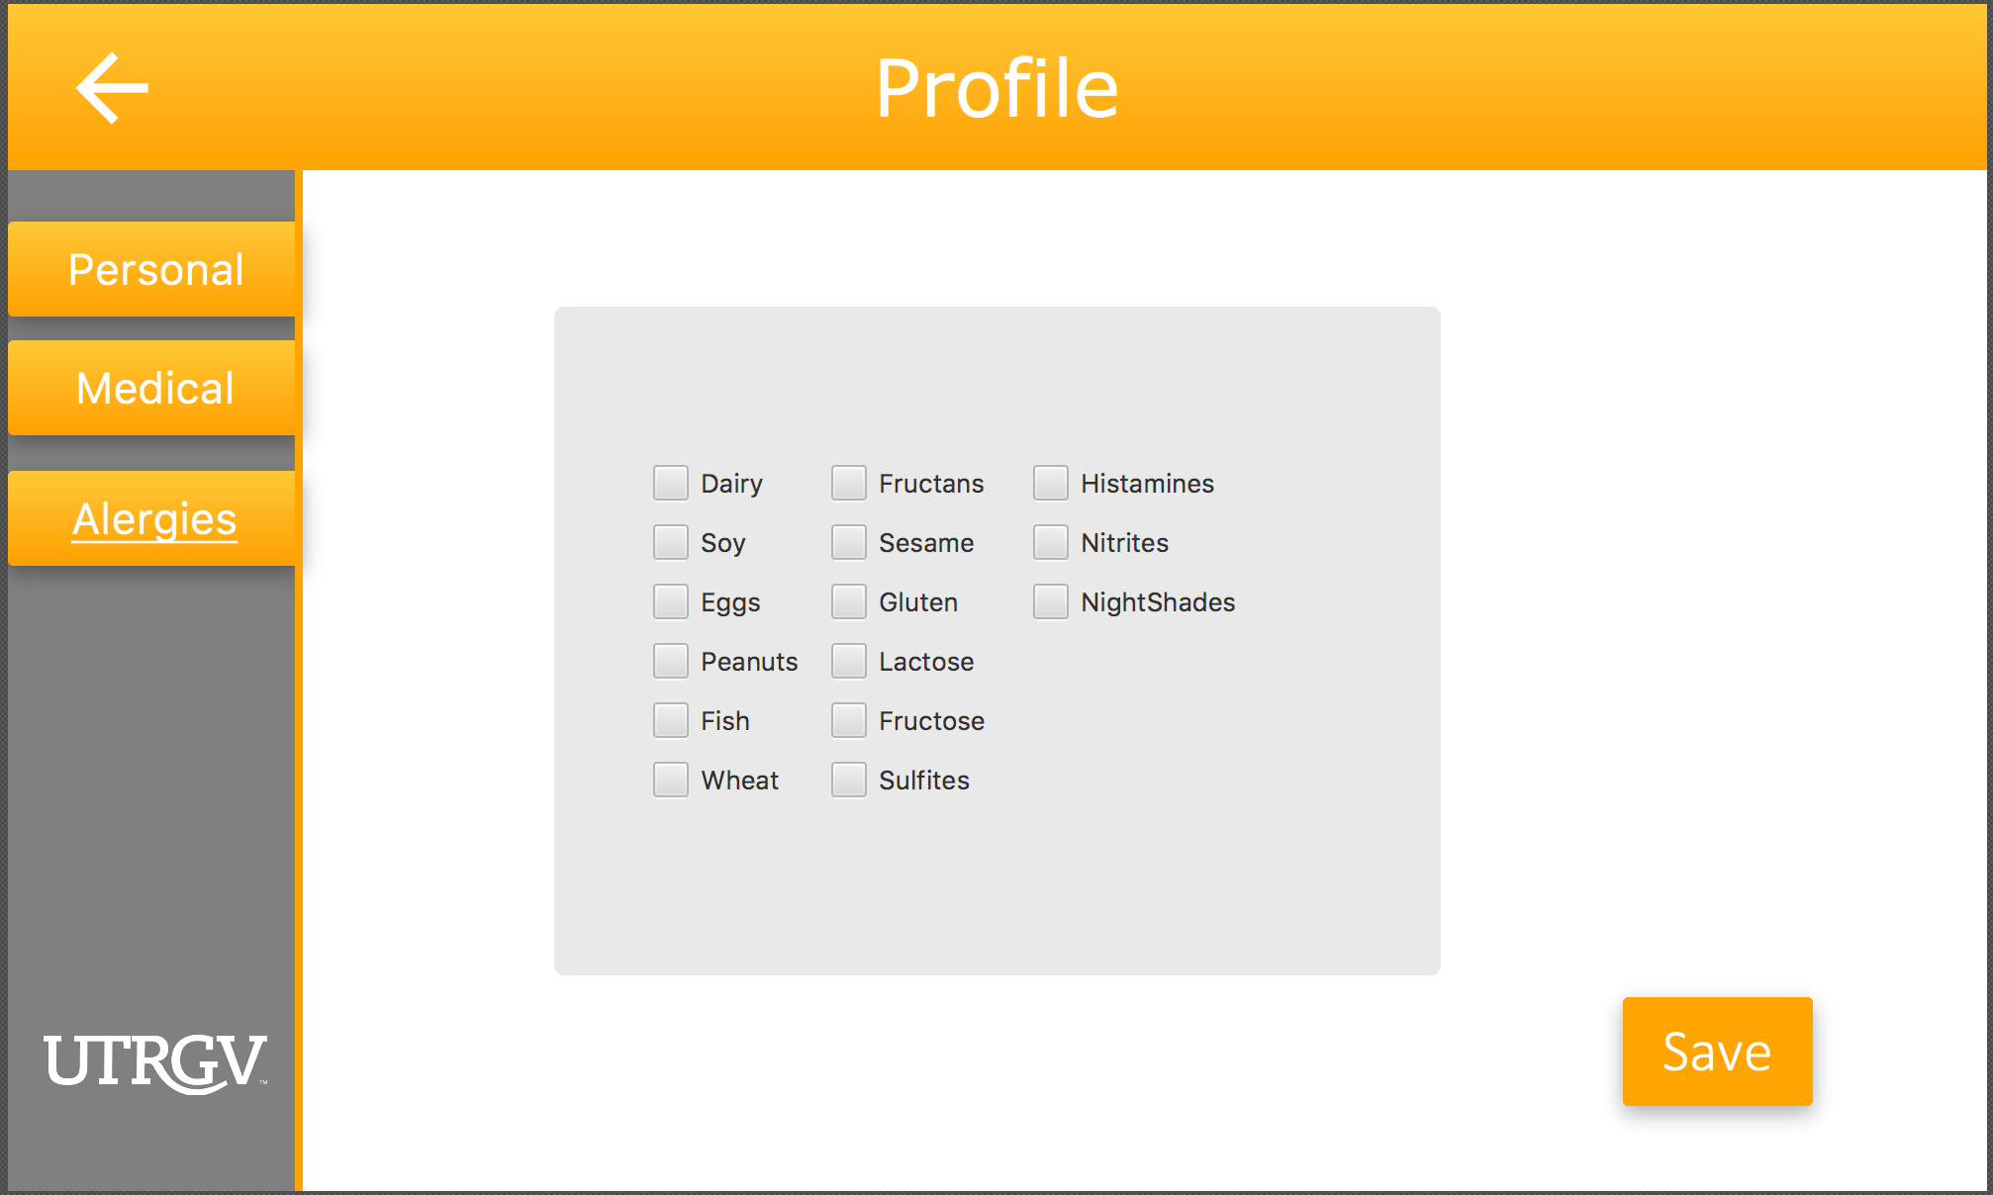

## A.7 Appendix 7

The following is an early stage of the exercise GUI design.

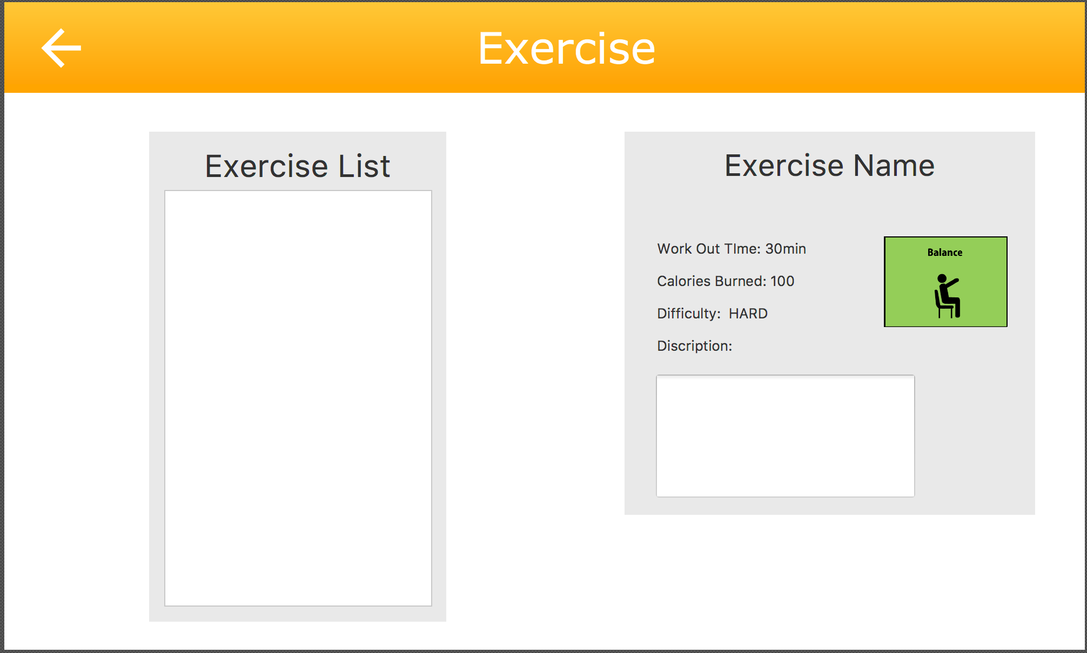

## A.8 Appendix 8

The following is ER diagram of the initial database design concept. The constraints will be implemented in the next version.

A screenshot of a cell phone

Description generated with very high confidence